MTH2010 Readings and Assignments: Week 4

Week 4 Readings
As early in the week as possible, please read:
- Week 4 online lectures.
- The following sections from the Chapter 6 (Circles) and Chapter 7 (Area of Polygons and Circles) of the text Elementary Geometry:
  - Section 6.1 pg. 276 (Also read examples 1-4),
  - Section 6.2 pg. 286 (Also read examples 1-4),
  - Section 7.1 pg. 336 (Also read examples 1-6),
  - Section 7.2 pg. 347 (Also read examples 1-6. Refer to the tables 7.1 and 7.2 on the pages 325 and 326 for the formulas for finding the perimeter of triangles and quadrilaterals.),
  - Section 7.3 pg. 357 (Also read examples 1-6),
  - Section 7.4 pg. 365 (Also read examples 1-8).
Week 4 Assignments Overview
Assignment Summary Week 4: | Due Date
Assignment 1: Discussion Questions | Friday, March 13, 2009
Assignment 2: Exam | Monday, March 16, 2009
Assignment 3: Discussion on Exam | Tuesday, March 17, 2009
Assignment 4: Team Activity | Tuesday, March 17, 2009

Week 4

Learning Outcomes:
- Identify properties of circles.
- Find measures of related segments and angles in the circle.
- Identify the different types of polygons.
- Find the areas and perimeters of polygons.
- Find the circumferences and areas of circles.
- Solve problems involving areas and perimeters of polygons and circles.

Circles
We encounter curved figures in our everyday lives as well as in geometry. This week, you will be working with circles, finding out the names of the various parts of a circle, and looking into the special angles in a circle.
By definition, a circle is the set of all points in a plane having the same distance from a fixed point. The fixed point is called the center of the circle. The distance between the center of the circle and any point of the circle is called the radius (plural: radii) of the circle. You can draw a circle using your compass. The spot where your metal compass point is located is the center of the circle, and the compass-setting distance is the radius of the circle. The compass-setting distance will remain the same while you draw your closed figure, i.e., your circle.
As we mentioned earlier, the radius is the distance between the center of the circle and any point of the circle. Basically, a radius is a segment that joins the center of the circle to a point on the circle. You can draw many radii in a circle, and they are all congruent. Two different circles are congruent if their radii are congruent.
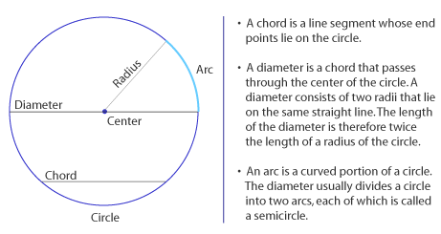
When we refer to the interior of a circle, we are looking at the set of all points whose distance from the center of the circle is less than the length of the radius of the circle. The exterior of a circle is the set of all points whose distance from the center of the circle is greater than the length of the radius of the circle.

Arcs and Central Angles
The length of an arc of a circle is usually expressed in linear units of measurement, such as inches, centimeters, and feet. We use degrees to represent the measure of an arc. A degree is a unit of measurement obtained by dividing one complete circle, or revolution, into 360 equal parts, and then referring to each part as a degree. A circle contains 360 degrees. In essence, the measure of an arc of a circle must be some fractional part of 360 degrees.
- A semicircle is an arc of a circle whose end points are the end points of a diameter of the circle; its measure is 180 degrees.
- A central angle is an angle whose vertex is at the center of the circle.
- A minor arc of a circle is an arc that lies in the interior of the central angle that intercepts the arc. The measure of a minor arc is the same as the measure of the central angle.
- A major arc of a circle is an arc that lies in the exterior of the central angle that intercepts the arc. The degree measure of a major arc is equal to 360 minus the measure of the central angle that determines the end points of the arc.
- The measure of an arc, as with angle measurement, is denoted by preceding the name of the arc with the letter "m." The measures of arcs can be added or subtracted in the same way that measures of angles and line segments are combined.
- Congruent arcs are arcs in the same circle or in congruent circles that have the same degree measure. You may have two circles that have the same center (called concentric circles) and yet if they are not congruent, then the arcs are not of the same measure, and therefore are not congruent.
- The midpoint of an arc is the point of the arc that divides the arc into two congruent arcs.
- In the same circle or in congruent circles, congruent arcs have congruent chords.
- In the same circle or in congruent circles, congruent chords intercept congruent arcs. Congruent chords are located at the same distance from the center of a circle.
- An angle inscribed in a semicircle is a right angle.

Tangent and Secants
A line may intersect a circle at no points, one point, or two points.
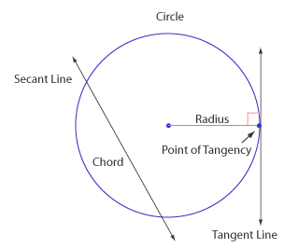
A tangent line is a line that intersects a circle in exactly one point. The point of contact is called the point of tangency. A radius drawn to a point of tangency is perpendicular to the tangent. The converse is also true. If a radius is perpendicular to a line at the point at which the line intersects a circle, then the line is a tangent.
A secant line is a line that intersects a circle in two different points. (Every secant line includes a chord of the circle.)
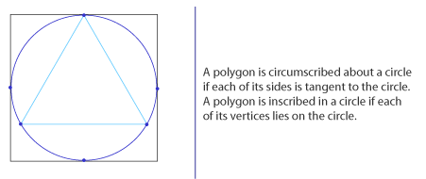
- An inscribed angle is an angle whose vertex lies on a circle and whose sides are chords (or secants) of the circle. Following that, the measure of an inscribed angle is equal to one-half the measure of its intercepted arc.
- The measure of an angle formed by a tangent and a chord drawn to the point of tangency is equal to one-half the measure of the intercepted arc.
- When two chords intersect at a point on the circle, then an inscribed angle is formed. If the chords intersect at a point in the interior of a circle (not at the center), then we will have two pairs of angles whose sides intercept arcs on the circle. The measure of an angle formed by two chords intersecting in the interior of a circle is equal to one-half the sum of the measures of the two intercepted arcs.
- The measure of an angle formed by two secants, a secant and a tangent, or two tangents intersecting in the exterior of a circle is equal to one-half the difference of the measures of the intercepted arcs.

Area Postulates
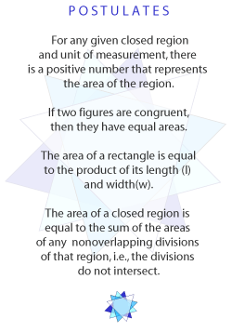
You begin your work on finding perimeters and areas of polygons and circles. When we talk about finding areas, we talk about finding areas of regions. A region is bounded if we can distinguish between its interior and exterior. There are some fundamental area postulates that you should be familiar with:
- For any given closed region and unit of measurement, there is a positive number that represents the area of the region.
- If two figures are congruent, then they have equal areas.
- The area of a rectangle is equal to the product of its length (l) and width (w).
- The area of a closed region is equal to the sum of the areas of any non-overlapping divisions of that region, i.e., the divisions do not intersect.
Sometimes, one side of a rectangle is referred to as the base and the adjacent side (which is perpendicular to the base) is called the altitude or height.
So, you may see the formula for the area of a rectangle being expressed as A = bh, where b represents the length of the base and h represents the height. The height or altitude will always be a segment that is perpendicular to the side that is specified as the base.
For example, let's say you are asked to find the area of a rectangle with a base of 12 centimeters and a height of 5 centimeters. Using the formula A = bh, you will have A = 12 x 5 = 60 cm².
Note that a square is a rectangle. So the area formula for a rectangle also applies to a square. If the length of a side of a square is represented by s, then the area of a square is given by the relationship A = s x s or A = s².
A rectangle is a special type of parallelogram. Any side of a parallelogram may be identified as the base of the parallelogram. The height or altitude of a parallelogram is the length of a segment drawn perpendicular to the base from any point on the side opposite to the base. The area of a parallelogram is equal to the product of the lengths of the base and the altitude drawn to that base, A = bh.

Perimeter and Area of Polygons

Triangle
When we draw a diagonal in a rectangle, we end up with two congruent triangles. What would the area of each triangle be? The area would have to be half of the area of the rectangle. So, we have the following: The area of a triangle is equal to one-half the product of the lengths of the base and the altitude drawn to that base, A = 1/2 bh.

Trapezoid
To find the area of a trapezoid, we draw a diagonal so that the trapezoid is divided into two triangles. The area of the trapezoid is given by the sum of the areas of the two triangles. Formally stated, the area of a trapezoid is equal to one-half the product of the length of an altitude and the sum of the lengths of the bases, A = 1/2 h(b₁ + b₂).

Rhombus
Note that the diagonals of a rhombus divide the rhombus into four congruent triangles. The area of a rhombus can be obtained by determining the area of one of these triangles and multiplying it by 4. If we refer to the lengths of the two diagonals of a rhombus as d1 and d2, then we have the area of a rhombus to be one-half the product of the lengths of the diagonals: A = 1/2 (d₁x d₂). The perimeter of a polygon is the sum of the lengths of all sides of the polygon.

Area of a Regular Polygon
You have seen how we can find the area for three-sided and four-sided polygons. There should be a way for us to find the area for any regular polygon. There are some definitions relating to regular polygons that need to be outlined first.
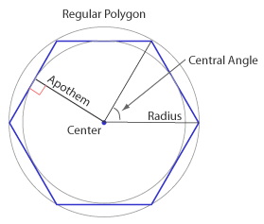

- The center of a regular polygon is the common center of its inscribed and circumscribed circles.

- An apothem of a regular polygon is a segment whose end points are the center of the polygon and a point at which the inscribed circle is tangent to a side. An apothem of a regular polygon is also a radius of the inscribed circle. An apothem of a regular polygon is the perpendicular bisector of the side to which it is drawn.

- A radius of a regular polygon is a segment whose end points are the center of the polygon and a vertex of the polygon. A radius of a regular polygon is also a radius of the circumscribed circle.

- A central angle is an angle of a regular polygon whose vertex is the center of the polygon and whose sides are radii drawn to the end points of the same side of the polygon. An n-sided regular polygon will have n central angles. The central angles of a regular polygon are congruent. The measure of the central angle of a regular polygon of n sides is given by c = 360/n.

Since an n-sided regular polygon is composed of n identical triangles, the formula for the area of a regular polygon is a generalization of the formula for the area of a triangle. The apothem of a regular polygon corresponds to the altitude of a triangle; the perimeter of a regular polygon corresponds to the base of a triangle.
Therefore, you will see that the area of a regular polygon may be found by multiplying one-half the length of the apothem by the perimeter of the regular polygon, i.e., A = 1/2 aP, where a is the length of the apothem, and P is the perimeter of the regular polygon.

Circumference and Area of a Circle

The distance around a polygon is called the perimeter of the polygon. We have a special name for the perimeter of a circle called circumference.
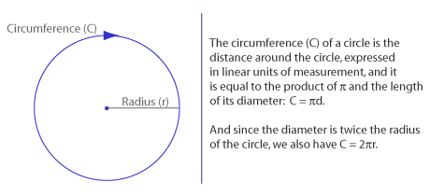
When you calculate the circumference of a circle, leave the symbol in the answer in order to state the exact result. For an approximate result, we can use 3.14 or 22/7. We read the symbol as "is approximately equal to."
As we know, the circumference represents the distance around the entire circle. We also have to be able to find the length (in linear units) of part of the circle, an arc of the circle. Since a circle contains 360°, the circumference of a circle represents the length of a 360° arc of the circle. The ratio of the length of an arc to the circumference must be equal to the ratio of the degree measure of the arc to 360°. So, we have: l / C = m / 360°. Once the circumference and the measure of the arc are known, we can find the length of the arc.
The area of a circle whose radius has length r is given by A = r². Similarly here, if we are asked for the approximate value of the area, use 3.14 or 22/7.

Assignment 1: Discussion Questions
By Friday, March 13, 2009 choose two of the discussion questions, and post your responses in the Discussion Area. Your response should reflect an understanding of the material covered as it applies to your life, work, and educational experiences. Start reviewing and responding to your classmates as early in the week as possible; post comments on at least two of your classmates' submissions to the Discussion Area. Please refer to the policy for participation found in the Educational Commitment Statement.
Grading Criteria | Maximum Points
Correct explanation of concepts. | 4
Well-formed conclusions. | 4
Participation in discussion with class, feedback, and comments. | 4
Correct spelling and grammar. | 4
Total: | 16
For assistance with any problems you may have when completing this assignment—OR—to offer your assistance to classmates, please use the Problems and Solutions Discussion area located through the left side navigation link.
DQ 1 - Consider a circle or congruent angles, and explain why each of the following statement is true:
- Congruent arcs have congruent angles;
- Congruent central angles have congruent arcs;
- Congruent chords have congruent arcs; and
- Congruent central angles have congruent chords.
DQ 2 - Is it possible for an inscribed rectangle in a circle to have a diameter for a side and a circumscribed rectangle about a circle to be a square? Explain.
DQ 3 - Suppose that two triangles have equal areas. Are the triangles congruent? Why or why not? Are two squares with equal areas necessarily congruent? Why or why not?
Week 4 exam
Quiz Questions 2, 6, 10, 12
2. In a given a triangle ABC, AB = 10, BC = 17, and AC = 21cm. What is the area of the triangle? (Points: 1)
78 cm2
80 cm2
82 cm2
84 cm<sup>2</sup>
6. A regular hexagon has sides of length 12 cm. If the length of the apothem is 6 3 cm, what is the area of the polygon? (Points: 1)
216 3 cm2
108 3 cm2
36 3 cm2
None of these
10. WXYZ is a trapezoid with segment WX being parallel to segment YZ. M is the midpoint of segment WZ and N is the midpoint of segment XY. If WX = 43, MN = 2x + 10, and ZY = 2x + 1, what is the value of x? (Points: 1)
10
12
14
None of these
12. Each side of a rhombus measures 10 inches. If one diagonal of the rhombus is 12 inches long, what is the length of the other diagonal? (Points: 1)
12 inches
16 inches
18 inches
8 �ã 2 inches

MATH 2010 Week 4: Assignment 4

Please answer the following questions. Some of the questions are from your text.

1. An airplane reaches an altitude of 3mi above the earth. Assuming a clear day and
that a passenger has binoculars, how far can that passenger see? (Hint: The radius
of the earth is approximately 4000 miles)

2. State the measure of the angle formed by the minute hand and the hour hand of a
clock when the time is a) 1:30pm and b) 2:20 am.

3. Suppose that a circle is divided into three congruent arcs by points A, B, and C.
What is the measure of each arc? What type of figure results when A, B, and C are
joined by segments?

4. Answer the following problem from your textbook: Problem 24 Section 7.1.

5. The lengths of the legs of a right triangle are consecutive even integers. The
numerical value of the area is three times that of the longer leg. Find the lengths of
the legs of the triangle.

6. Answer the following problem from your textbook: Problem 26 Section 7.1.

7. Answer the following questions from your textbook: Problems 33 and 34 Section 7.2.

8. The radius of a Ferris wheel’s circular path is 40 ft. If a “ride” of 12 revolutions is
made in 3 minutes, at what rate in feet per second is the passenger in a cart moving
during the ride?

